Name: Cargile, Christopher
Student access ID: 10059306
Project: JEdit
Change Number: 3
Date: 10/17/2013
Team Number: 2

Change Request #3:”Search and mark all”

- Change Request:
The change request to incorporate, verbatim, was: “Under menu Search, add menu item “mark all”. Locate all matches and add markers to all of the lines.” The jEdit codebase that was checked out comes with a GUI look-and-feel that includes a standard file-menu with Search tab. Under the tab for ‘Search,’ menu options available and associated with ‘find’ included: find, find next, and find previous. If jEdit is compiled using a compatible version of the JDK, the GUI will either prompt the user to enter search criteria, of if text is selected in the jEdit window pane that is open, a search pane that pops up will be presented with the highlighted term pre-populated in the ‘Search For’ input-text container. It seems adequate the ‘Find And Mark All’ option could be listed below the ‘Find’,’Find Next’, and ‘Find Previous’ menu options for ‘Search.’ The find-and-mark-all menu choice, if successfully implemented, will not be evident to the user after completing until the user opts to view markers (under the ‘Markers’ menu tab), at which point each line that contains a match for the search criteria will be represented as being ‘marked,’ there.

- Concept Location:
The concept location methodology that was used consisted of a combination of approaches, the primary of such was either to identify the relevant files via JRipples’ GREP text analysis means or usage of Eclipse’s Search: Files utility. JRipples’ GREP searching was useful to first identify a list of classes that contained main() methods, from which to begin inspecting jEdit. From there, hovering the classes to view the Java tooltip, then selecting ‘Open Declaration’ to inspect the classes’ code and/or methods (via e.g.: Eclipse’s Outline perspective) was used to search for the concept’s location by examining the calls from the main() program runners main/run method. As this examination did not reveal the concept location, nor reveal much detail about how the program actually was functioning I ran searches against the “marker”,”search”, and “mark” search keys and had better luck. Deducing that Actions.xml and jedit.props.xml likely need to be changed is probably more a matter of informed-intuition, based upon examining the format of those two files; by inspecting several parts of the controlling mechanisms inside jedit that seemed vital and realizing that these parts rely on data that retrieved by calls to getProperty()-type (system.getProperty(), et al) methods, it was evident the default property values would have impact on the system – and indeed they define most of the functional aspects of the GUI (layout-containers declarations and hardcoded property-file filenames) from initSystemProperties() and initResources() inside main().

Table 1. Classes visited during concept location.
# | File name | Tool used | Located? | Comments
1 | Buffer.java | JRipples GREP search | Yes; several seemingly pertinent methods were present | Unchanged - buffer seemed like a perfectly suitable match for implementing the CR at first, but further analysis revealed there might be an easier means.
2 | EditPane.java | JRipples GREP search/java text search | Yes; addMarker() seems highly likely to fit the need | Unchanged; the addMarker() method is distinct from the same method with a different signature implemented in Buffer.java
3 | SearchAndReplace.java | JRipples GREP search; Eclipse Search-> File | Yes | Changed
4 | propMgr.java | n/a; self-initiated search following investigation of jEdit.main() | No | Unchanged; this class was not identified by JRipples and was not relevant in anyway other than by assisting with the ‘glue’ b/n GUI and main()
5 | View.java | n/a; self-directed investigation led me to view.java | No | Unchanged; after finding that ‘view’ was a required parameter for many methods in SearchAndReplace, it seemed possibly relevant and able to indicate the inner mechanisms connectng the program and GUI.
6 | Actions.xml | Eclipse->Search utility | Yes | Changed
7 | Jedit.props.xml | Eclipse->Search utility | Yes | Changed
8(~ 15?) | (many files) | Various other methods, including java text search/java right-click option selection: References->Project, and self-initiated manual inspection | Essentially, no | Examining several non-utilized classes helped me identify a possible solution and better grasp the files at work in the BeanShell script-driven program environment in which jEdit runs.

- Impact Analysis:
Because the codebase is relatively large, it would likely seem as reasonable to describe jEdit in terms of the modules(packages) which it uses, but because the impact set associated with the change request is not overly cumbersome in terms of files modified nor diversity of the new functional requirements*, a small enough number of classes can be explained in terms of their purpose and bearing on the change requested. SearchAndReplace.java is among the most significantly modified of files in the impact set. Its package includes a variety of search-related behavioral-drivers(methods/classes), but SearchAndReplace.java, itself, contains the find([..]) method(s). To implement the changes requested, it is realized that find() must remain distinct from any method calls which involve changing the marker locations. However, if find were able to be slightly modified, it could be a somewhat simple overhaul required to accommodate finding and marking a location in the same step – say using find_and_mark() instead of find(). Upon implementing find_and_mark(), work remains such that a method to find-and-mark-all instances of the matching search pattern does not have a counterpart, anywhere in the codebase, per se – there is no method with the name of or capability for executing a find-all using jEdit. To achieve find-and-mark-all, we would need a find-and-mark means that could be called on a case-by-case basis, as well as a method that could be invoked in a continual basis until the entire file(set) was searched.

The specification does not indicate whether the feature needs to be capable of searching more than one buffer, so we will limit our feature functionality to only searching the buffer/editpane that has the current focus.

Multiple files were examined using JRipples’ GREP Analysis technique during the CL phase but fewer files will need examining during IA because the files were modified to incorporate functionality that was novel and therefore did not pose the threat of backwards imcompatibility. As an aid in examining the files during the CL phase, it would be very helpful if Eclipse presented the ‘bookmark’ view as a default View choices, so it could be discovered more easily by newcomers and if the Eclipse text editor made expanding/collapsing on loops and {}’d code parts possible (like Notepad++ does/Eclipse did?). The ‘parse-args’ style for-loop in main() is lengthy and would be nice to collapse it for quicker analysis of the rest of main() method.

*Perhaps per direction of RE recommend practices/agile development methods, the guidance in place ensured each ticket involves a maximum of only one type of change functionality, so describing the impact set becomes manageable.

Table 2. Classes visited during impact analysis.
# | Class name | Tool used | Impacted? | Comments
1 | SearchAndReplace.java | JRipples GREP text analysis | Yes | SearchAndReplace.find()contains behavior that can be almost replicated to produce the desired effect but needs to be enhanced, slightly.
2 | Actions.xml | Java Search -> File utility. | Yes | This file lists the behaviors associated with the user-input as ‘heard’ by the GUI listeners.
3 | jedit_gui.props.xml | Java Search -> File utilitiy | Yes | This file lists GUI configurations & declares data the GUI/controller binding mechanism will require.
4 | MISCUtilities.java | n/a; inspected without much reason | No | File is insignificant to CR#3
5 | GUIUtilities.java | n/a; inspected without much reason | No | File is insignificant to CR#3
6 | jEdit.java | n/a; inspected without much reason | No | File is insignificant to CR#3
7 | Macros.java | n/a; inspected without much reason | No | File is insignificant to CR#3
8 | BeanShell.java | n/a; inspected without much reason | No | File is insignificant to CR#3

- Learning process:
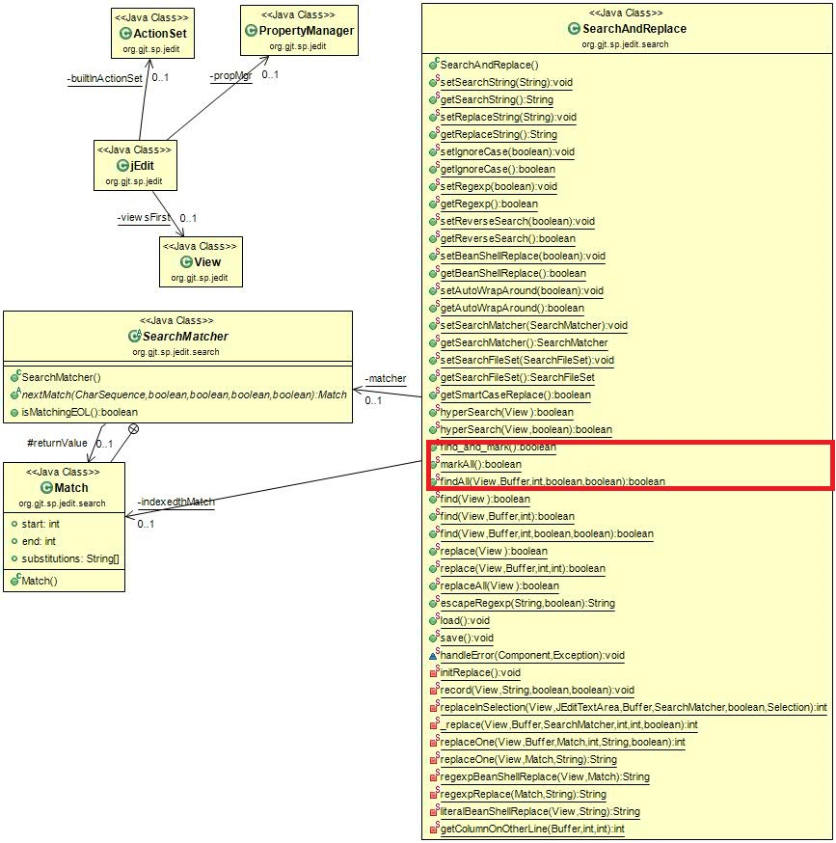
Figure 1. CLIA class diagram showing: change request #3 affected classes

